**User guide**

**1. Installing the software**

The user has two options to run FRAP Toolbox, 1) using the source files and a full installation of MATLAB; or 2) as a standalone application by first installing the royalty-free MATLAB Compiler Runtime.

The user can download source files, as well as the test datasets at: <https://github.com/kraftlj/FRAP-Toolbox>.

The user can download the standalone application and test datasets at: <https://sites.google.com/site/annekenworthylab/home/frap-toolbox>.

* 1. **System requirements**

FRAP Toolbox has been tested on a PC running 32 bit Windows XP and 64 bit Windows 7, as well as a MAC running OS X 10.9.

MATLAB 2013 has the following system requirements:

| Operating Systems | Processors | Disk Space | RAM |
| --- | --- | --- | --- |
| Windows 8.1  Windows 8  Windows 7 Service Pack 1  Windows Vista Service Pack 2  Windows XP Service Pack 3  Windows XP x64 Edition Service Pack 2  Windows Server 2012  Windows Server 2008 R2 Service Pack 1  Windows Server 2008 Service Pack 2  Windows Server 2003 R2 Service Pack 2 | Any Intel or AMD x86 processor supporting SSE2 instruction set | 1 GB for installation of MATLAB | 1024 MB (At least 2048 MB recommended) |
| Mac OS X 10.9 (Mavericks)  Mac OS X 10.8 (Mountain Lion)  Mac OS X 10.7.4+ (Lion) | All Intel-based Macs with an Intel Core 2 or later | 1 GB for MATLAB only, 3–4 GB for a typical installation | 1024 MB (At least 2048 MB recommended) |

**1.2 Included Files**

The following source files are located in the *FRAP Toolbox* directory:

|  |
| --- |
| *bfCheckJavaPath.m* |
| *bfGetPlane.m* |
| *bfGetReader.m* |
| *bfopen.m* |
| *DiffusionModel_2.m* |
| *Figure_GUI_Diffusion.m* |
| *Figure_GUI_FRAP_FRET.m* |
| *Figure_GUI_NCtransport.m* |
| *Figure_GUI_NCtransport2.m* |
| *Figure_GUI_Reaction.m* |
| *FRAPcurve_Diffusion.m* |
| *FRAPcurve_FRAP_FRET.m* |
| *FRAPcurve_NCtransport.m* |
| *FRAPcurve_NCtransport2.m* |
| *FRAPcurve_Reaction.m* |
| *FRAP_FRET_Model.m* |
| *InitialConditions_Diffusion.m* |
| *InitialConditions_FRAP_FRET.m* |
| *KangFRAP.m* |
| *LICENSE* |
| *loadData_Diffusion.m* |
| *loadData_FRAP_FRET.m* |
| *loadData_NCtransport.m* |
| *loadData_NCtransport2.m* |
| *loadData_Reaction.m* |
| *loci_tools.jar* |
| *Main_GUI.m* |
| *NCtransportModel.m* |
| *NCtransportModel2.m* |
| *NormalizeFRAP_Diffusion.m* |
| *NormalizeFRAP_FRAP_FRET.m* |
| *NormalizeFRAP_NCtransport2.m* |
| *NormalizeFRAP_Reaction.m* |
| *PhotoDecay.m* |
| *PhotoDecay_FRAP_FRET.m* |
| *PreviewGUI_Diffusion.m* |
| *PreviewGUI_NCtransport.m* |
| *PreviewGUI_Reaction.m* |
| *Reaction1Model.m* |
| *Reaction2Model.m* |
| *README.md* |
| *ROIinitialization_Diffusion.m* |
| *ROIinitialization_FRAP_FRET.m* |
| *ROIinitialization_NCtransport.m* |
| *ROIinitialization_NCtransport2.m* |
| *ROIinitialization_Reaction.m* |
| *Test Data* |
| *User guide.docx* |
| *User guide.pdf* |

The following files are located in the *Windows x32 Deployment/FRAP Toolbox* folder:

*FRAPToolbox.exe*

*MCR_R2013a_win32_installer.exe*

*loci_tools.jar*

The following files are located in the *Windows x64 Deployment/FRAP Toolbox* folder:

*FRAPToolbox.exe*

*MCR_R2013a_win64_installer.exe*

*loci_tools.jar*

The following files are located in the *MAC Deployment\FRAP Toolbox* folder:

*FRAPToolbox.app*

*MCR_R2013a_maci64_installer.zip*

*loci_tools.jar*

**1.3** **Running FRAP Toolbox using MATLAB**

In MATLAB, navigate to the *FRAP Toolbox* directory containing the source files. Open and run *MainGUI.m*

**1.4 Setting up FRAP Toolbox as a standalone application**

**1.41 Instructions for a PC**

1. Move the folder *Windows x32 Deployment\FRAP Toolbox* to a suitable location, *C:\FRAP Toolbox*, on your hard drive.
2. Install the MATLAB Compiler Runtime, *MCR_R2013a_win32_installer.exe*,by double clicking on the file, and following the on screen instructions.
3. Open *classpath.txt* for editing. By default this file is located in *C:\Program Files\MATLAB\MATLAB Compiler Runtime\v81\toolbox\local\classpath.txt*.You need to first give yourself administrative privileges for editing *classpath.txt* by right clicking the file, click properties, click Security, click Edit…, and giving Full control to Users. Press OK to save the changes giving you rights to edit *classpath.txt*. On a new line, at the end of the file, append the text file with, *C:\FRAP Toolbox\loci_tools.jar*. Save the changes before closing.
4. You can now run *FrapToolbox.exe* by double clicking the file.

Note: you can place the FRAP Toolbox directory in any desired location on your hard drive, but be sure to add the correct path to *loci_tools.jar* in *classpath.txt*.

**1.42 Instructions for a MAC**

1. Move the folder *FRAP Toolbox* to the location, */FRAP Toolbox*, on your hard drive.
2. Install the MATLAB Compiler Runtime, *MCR_R2013a_maci64_installer.zip*, by double clicking on the file, and following the on screen instructions.
3. Open *classpath.txt* for editing. By this file is located in /Applications/MATLAB Compiler/v81/toolbox/local/classpath.txt. You may need to give yourself administrative privileges in order to navigate beyond the *MATLAB Compiler* folder. On a new line, at the end of the file, append the text file with, */FRAP Toolbox/loci_tools.jar*. Save the changes before closing.
4. You can now run *FrapToolbox_Mac.app*

Note: you can place the FRAP Toolbox directory in any desired location on your hard drive, but be sure to add the correct path to *loci_tools.jar* in *classpath.txt*.

**1.5 Overview of the software**

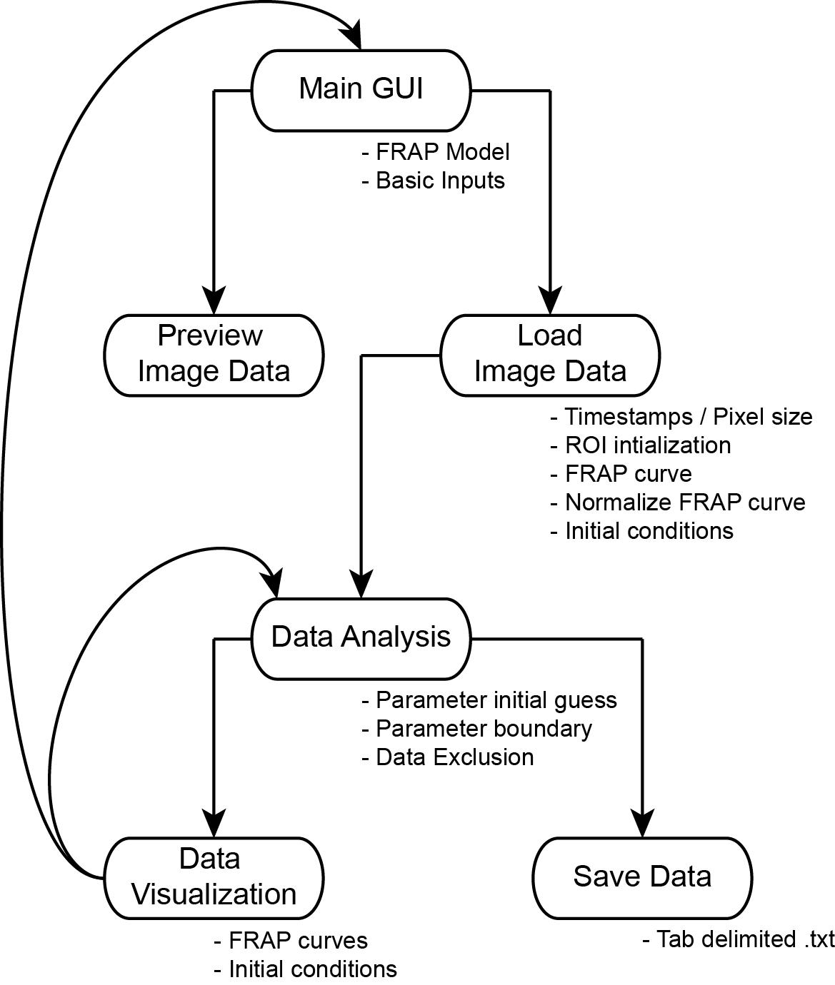

**1.6 Supported Image Formats**

FRAP Toolbox directly opens raw image formats by integrating with Bio-Formats – a standalone Java library for reading and writing life science image file formats [1]. For a full list of the supported image formats by Bio-Formats see <http://www.openmicroscopy.org/site/support/bio-formats4/supported-formats.html>. We have verified FRAP Toolbox correctly reads *.lsm* and *.nd2* raw image formats from Zeiss and Nikon microscopes.

**1.7 Considerations for designing FRAP experiments for analysis with FRAP Toolbox models**

**1.71 Diffusion**

The Bleach ROI geometry must be circular. The user should record the (x,y) center of the ROI, as well as its radius (units are in pixels).

The user must record the frame number of the post-bleach image.

The user must independently measure the mean background intensity from unlabeled samples. Often background fluorescence can be approximated as zero.

Normalizing the FRAP curve by the mean intensity of the whole cell requires the user to acquire images that capture the entire cell within the frame.

The user must acquire at least one pre-bleach image such that the FRAP curves can be normalized.

If the FRAP curves are not normalized by the mean intensity of the whole cell, the rate of unintentional photobleaching must be taken into account. FRAP Toolbox can model this slow decay as a single exponential if the user carries out the recovery for a period of time after complete recovery. Alternatively, the user can measure the decay due to imaging using independent control samples, and input a decay constant as a fixed parameter in FRAP Toolbox. Note that decay due to imaging, as well as loss of fluorescence in a compartment due to the bleaching event are both inherently corrected if the images are normalized by the mean intensity of the cell.

**1.72 Reaction 1 and Reaction 2 models.**

Bleach ROI geometry can be circular or a user defined polygon. If the bleach geometry is circular, the user should record the (x,y) center of the ROI, as well as its radius (units are in pixels).

The user must record the frame number of the post-bleach image.

The user must independently measure the mean background intensity from unlabeled samples. Often background fluorescence can be approximated as zero.

Normalizing the FRAP curve by the mean intensity of the whole cell requires the user to acquire images that capture the entire cell within the frame.

The user must acquire at least one pre-bleach image such that the FRAP curves can be normalized.

**1.8 FRAP models and their applications**

**1.81 Diffusion**

The Diffusion model is useful for simulating FRAP recoveries dominated by single component Brownian motion. The Diffusion model is a closed form analytical equation for extracting an instrument independent diffusion coefficient [2]. The model has several assumptions: 1) a homogeneous distribution of molecules; 2) a complete bleach trough the sample in the z-direction such that diffusion occurs in two dimensions; 3) infinite boundary conditions; and 4) a single diffusing component.

Denote the mean fluorescence intensity within the bleach region as, *I*(*t*)*. I*(*t*) is normalized to the pre-bleach steady-state intensity. The diffusion coefficient *D* and mobile fraction *Mf* are found by fitting the data to the FRAP model,



where *I0*is 1 for a normalized FRAP curve, and *rn* is the nominal radius of the bleaching ROI.[2] This is a modified form of the Axelrod equation[3] where the laser is assumed to be a Gaussian, and the parameters *re* and *K* take into account the initial conditions for the solution of the diffusion equation. We determine *re* and *K* by fitting the normalized radial post-bleach profile, *I*(*x;t=0*), to an analytical approximation,



where *I0*is 1 for a normalized post-bleach profile, and *x* is the radial distance from the center of the bleaching ROI.[4]

**Corrections**

To correct for unintentional photobleaching during the imaging as well as loss of fluorescence in the compartment due to the bleaching event, we divide by the integrated intensity of the whole cell. Alternatively, unintensional photobleaching can be corrected by approximating it as a single exponential decay process at time points after the fluorescence has once again reached steady-state,



*kdecay* is the unintentional photobleaching rate constant.

The loss of fluorescence in the compartment due to the bleach leads to misleading mobile fractions less than 1 unless this is corrected. To do this we measure the intensity inside and ROI adjacent to the bleach region and correct by,



**Curve fitting parameters**

*K, re*, *D*, *Mf*, *kdecay*, *Mfcorrect*

**1.82 Reaction 1**

The Reaction 1 model simulates FRAP recoveries that can be modeled using a single component exponential function. As an example, consider molecules that are either free to diffuse *f*, or bound in an immobile complex *c*,



Assuming *f* equilibrates rapidly in the bleach region,  , and the differential equation governing the change in the concentration of complex over time is,



 and  are the pseudo-on-rate and off-rate for complex formation respectively. In this case, the FRAP curve is modeled using,



**Curve fitting parameters**

,

**1.83 Reaction 2**

The Reaction 2 model simulates FRAP recoveries that can be modeled using a two component exponential function. As an example, consider molecules that are either free to diffuse *f*, or bound in an immobile complex *c1*, or a second immobile complex *c2*,



In the same fashion as in the example presented for the reaction 1 model, assuming *f* equilibrates rapidly in the bleach region,  , and the differential equations governing the change in the concentration of complex over time is,



**Figure 1. FRAP Toolbox begins with a main window requesting several basic inputs from the user.** First, the user must navigate to the location of saved FRAP datasets on their computer or network (these are raw microscope files, in this case named 1.lsm, 2.lsm, 3.lsm, ...). The user can select one or more of these files at a given time depending on whether they wish to process them all at once or one at a time (note batch processing requires all datasets to have the same structure). Next, the user must select a suitable model for data fitting, the geometry of the bleaching ROI, the frame number for the first post-bleach image, background fluorescence intensity, as well as options for data normalization. Finally, the user can either preview their settings and dataset using the preview button, or proceed to the data analysis screens.

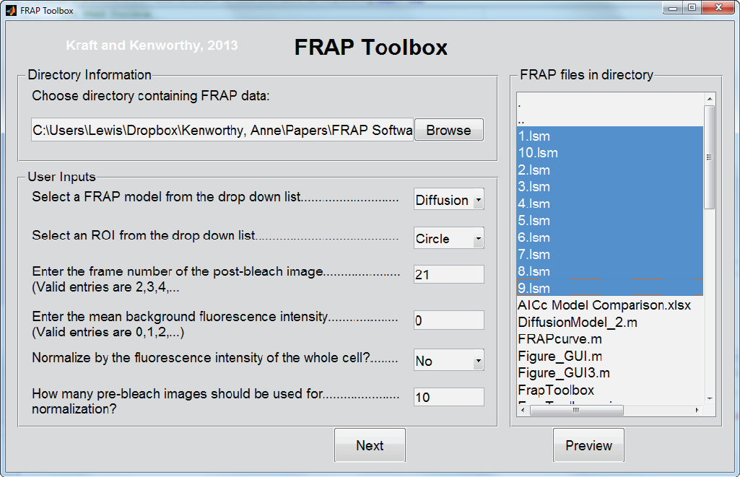

where  and ,and , and and ** are the pseudo-on rates the off rates, and the concentrations for the first and second complexes. In this case, the FRAP curve is modeled using,



**Curve fitting parameters**

** ,  ,  , **

**1.9 Using the software**

FRAP Toolbox begins with a main window (**Figure 1**), which requires the user to provide several basic inputs. The first input is the location where raw FRAP data is stored. The files in the selected directory appear in a right hand panel, which allows the user to select one or more files. In the example in Figure 1 we selected 10 FRAP datasets which were acquired with a Zeiss LSM 510, and have the raw file extension *.lsm*. For these datasets we photobleached a circular region in the nucleus of COS7 cells expressing the Venus fluorescent protein. Next, the user must enter a set of basic inputs including which model to use for the data analysis, the geometry of the bleaching ROI, the image frame number of the bleaching event, a constant background intensity (experimentally determined with unlabeled controls), an option to correct the fluorescence intensity using the mean intensity of the whole cell, as well as the number of pre-bleach images that should be used for normalization purposes. Finally, the user will either choose to preview their settings by loading and visualizing the first FRAP data set, or the user will press the next button to proceed to data fitting and data saving.

Pressing the image preview button on the main window will load the first FRAP data set selected in the list of files (**Figure 2**). The previewing window includes a scroll bar at the bottom to allow previewing of each image in the image stack, and will also plot a predefined bleaching ROI. If instead the user proceeds to data fitting and data saving by pressing the next button, FRAP Toolbox will load all of the selected FRAP data sets using the Bio-Formats library for reading and writing life sciences image file formats[1]. A new data analysis and visualization window will pop up after the data is finished loading (**Figure 3**). In this example, we chose to use the FRAP Toolbox diffusion model, and loaded all 10 FRAP data sets as was shown in Figure 1. The data analysis and visualization window (**Figure 3**) consists of three parts. The first part allows the user to provide several basic inputs to the fitting process, namely, initial guesses on fitting parameters, boundaries on fitting parameters, as well as an option to exclude data points (for example, the fitting can be constrained to early time points).

Next, the user will press the Run button to fit the FRAP data. As the software finishes the fitting routine, several windows will automatically pop up to provide the user with the ability to visually inspect the results of the fitting routine. For the case of the diffusion model, the initial conditions are plotted, as well as the diffusion model fits to the FRAP curves. The optimized parameters from the fitting routine are automatically uploaded in tabular form (**Figure 3)**. These optimized parameters, the raw FRAP data, as well as the processed FRAP data, and fits to the FRAP data may now be conveniently saved to text files by pressing the save button in the data analysis and visualization window (**Figure 3**). Thus, with a few steps, the FRAP Toolbox provides users with easy access to the latest advancements in quantitative FRAP data analysis.

**Figure 3. The data analysis and visualization window allows the user to customize their fitting routine, as well as view and save the results.** In the left panel the user has the option of inputting specific initial guesses, and lower and upper bounds for the fitting parameters. In addition, the user has the ability to specifically control how many data points should be fit (often the user will not want to include data points after the fluorescence has plateaued. The user can specify if all of the FRAP data sets should be fit individually or if the FRAP data sets should be averaged together before fitting. In the right panel the optimal parameters returned by the fitting routine are displayed in table form. In addition, the user can choose to exclude certain datasets by toggling them on and off in the far right panel. After the user is satisfied with the results of the fitting routine there is a button which will save the data as a tab delimited text file.

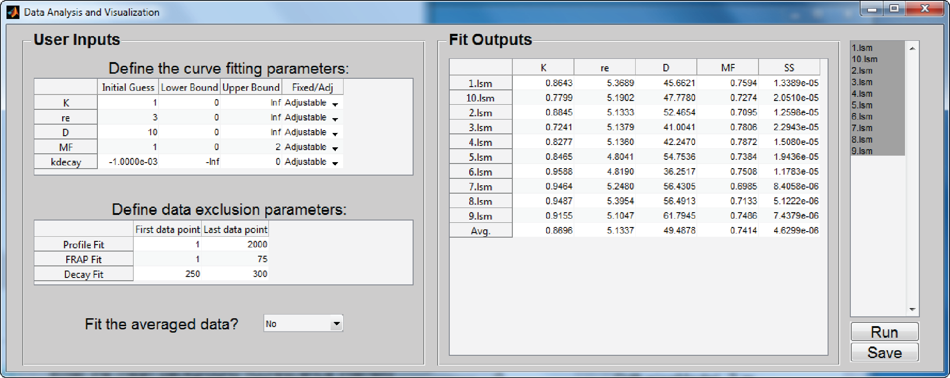

**Figure 2. Previewing a FRAP dataset allows the user to verify the correctness of basic inputs.**

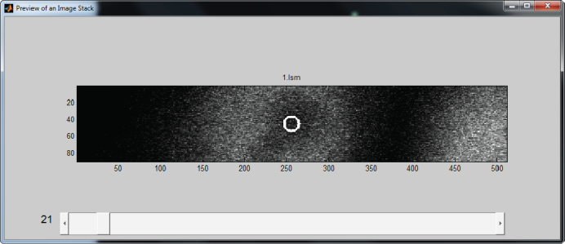

**1.10 Data presentation**

Next, the user will press the Run button to fit the FRAP data. As the software finishes the fitting routine, several windows will automatically pop up to provide the user with the ability to visually inspect the results of the fitting routine (**Figure 4**). For the case of the diffusion model, the initial conditions are plotted, as well as the diffusion model fits to the FRAP curves. The optimized parameters from the fitting routine are automatically uploaded in tabular form (**Figure 3)**. These optimized parameters, the raw FRAP data, as well as the processed FRAP data, and fits to the FRAP data may now be conveniently saved to text files by pressing the save button in the data analysis and visualization window (**Figure 3**). Thus, with a few steps, the FRAP Toolbox provides users with easy access to the latest advancements in quantitative FRAP data analysis

**1.11 Troubleshooting**

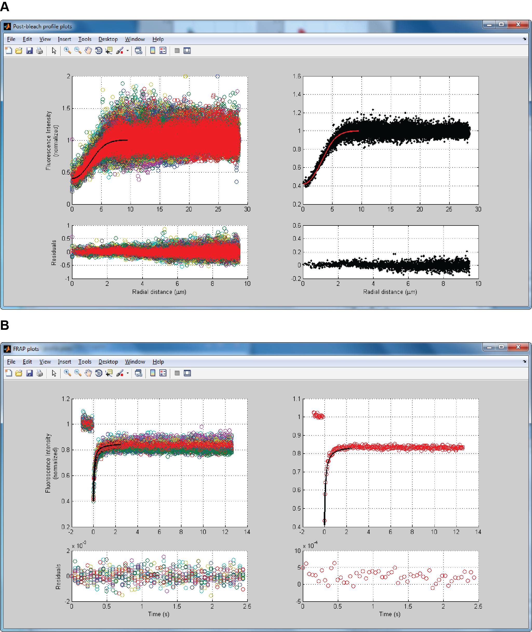

**Figure 4. Diffusion model popup windows allow easy inspection of the curve fitting results.** (**A**) In the left panel the radial post-bleach profiles and fits from each individual data set are displayed along with fits and residuals; in the right panel the average post-bleach profile for all datasets and fit is displayed. (**B**) In the left panel the normalized FRAP curves from each individual data set are displayed along with fits and residuals; in the right panel is the average FRAP curve for all datasets and optimized model with residuals.

FRAP Toolbox has several built in warning dialogs which will display when it detects potential errors. For example, when batch processing; all of the datasets must have been acquired using identical settings. If the user attempts to batch process data acquired under different conditions, FRAP Toolbox automatically detects this, and informs the user with an error dialog. If users come across bugs they are encouraged to report these using the issue reporting feature on the FRAP Toolbox website at: [https://github.com/kraftlj/FRAP-Toolbox/issues](https://github.com/). Or by contacting us directly via email: <https://sites.google.com/site/annekenworthylab/home/contact-us>.

***References***

1. Linkert, M., et al., *Metadata matters: access to image data in the real world.* Journal of Cell Biology, 2010. **189**(5): p. 777-782.

2. Kang, M., et al., *A generalization of theory for two-dimensional fluorescence recovery after photobleaching applicable to confocal laser scanning microscopes.* Biophysical journal, 2009. **97**(5): p. 1501-11.

3. Axelrod, D., et al., *Mobility measurement by analysis of fluorescence photobleaching recovery kinetics.* Biophys J, 1976. **16**(9): p. 1055-69.

4. Braga, J., J.M. Desterro, and M. Carmo-Fonseca, *Intracellular macromolecular mobility measured by fluorescence recovery after photobleaching with confocal laser scanning microscopes.* Mol Biol Cell, 2004. **15**(10): p. 4749-60.